Q1- <https://www.ultimateqa.com/simple-html-elements-for-automation/>

Fetch Quality Assurance Engineer Salary from the table under HTML Table with no id.

The code should be dynamic.

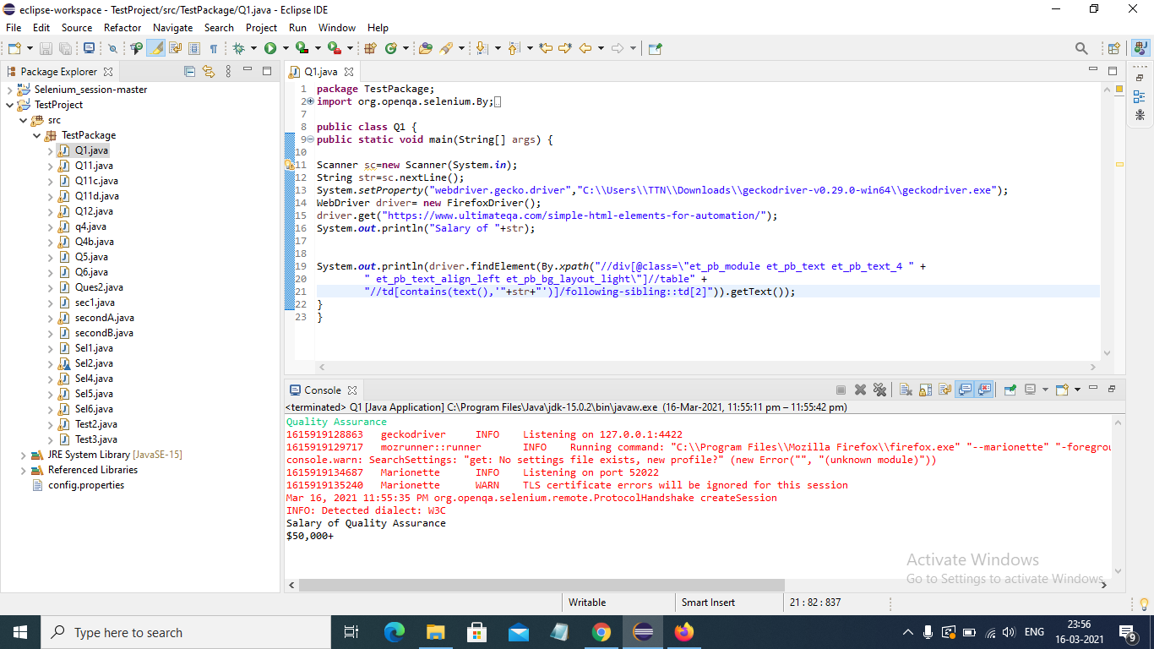

Q2- Write an automation script for filling all fields of the registration page. (Registration.html)

But make sure that test data should be provided from a properties file.

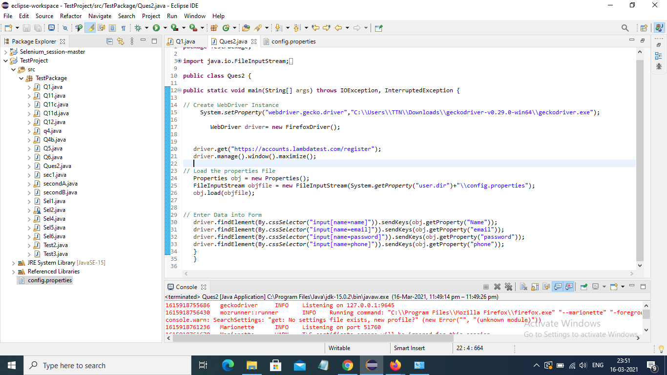

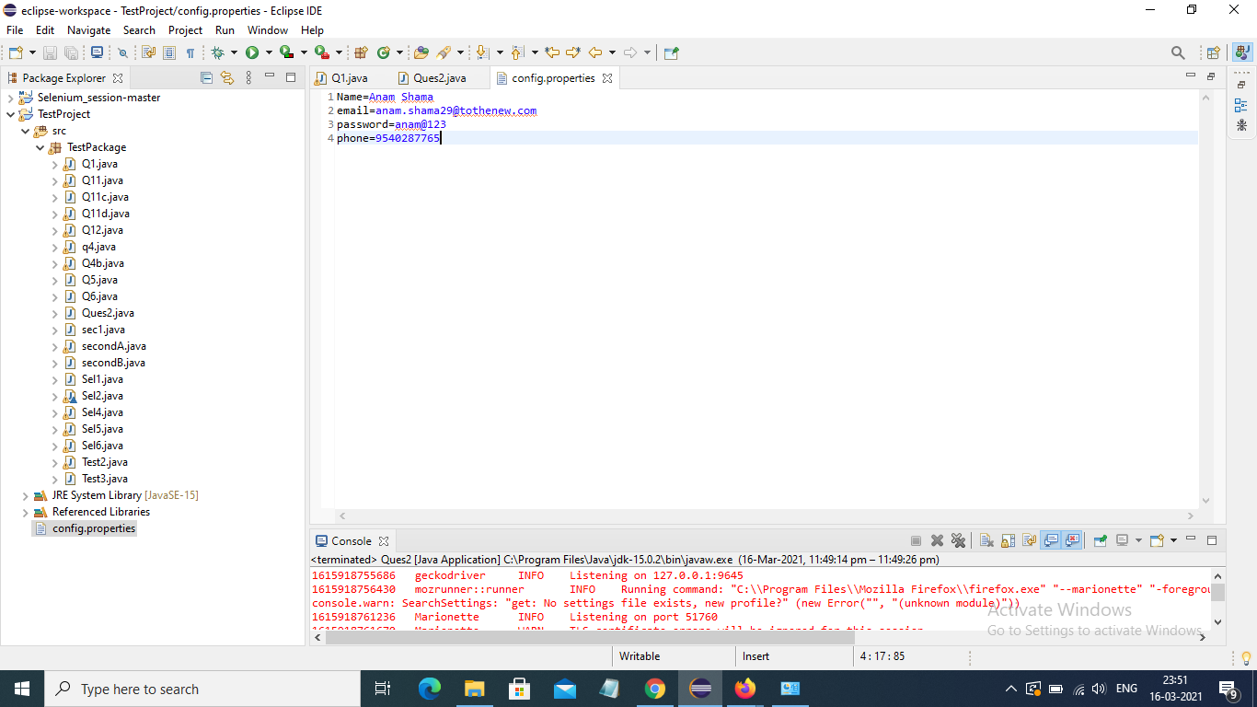

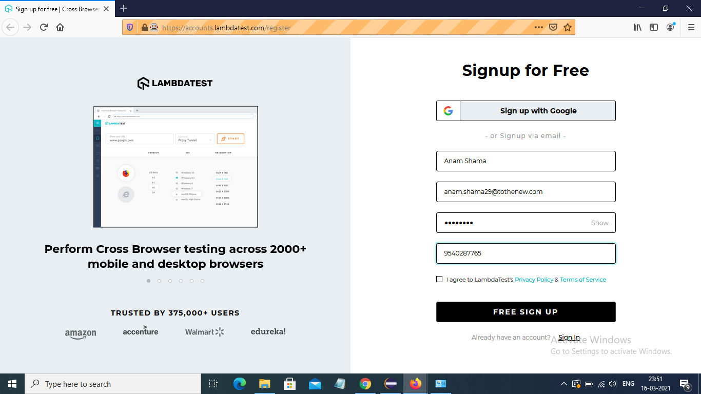

Q3- What are the advantages of TestNG & TestNG annotations?

Ans: The main advantage of testNG can be listed as follows:

* TestNG provides parallel execution of the test method.
* It allows to define dependency of one test method over other method
* It allows to assign priority to test methods
* It allows grouping of test methods into test groups
* It has support for parameterizing test cases using @Parameters annotation
* It allows data driven testing using @DataProvider annotation
* It has different assertions that helps in checking the expected and actual results
* Detailed (HTML) reports

TestaNG Annotations:

* @BeforeSuite: TestNG BeforeSuite method will run before all tests in this suite have run.
* @AfterSuite: TestNG AfterSuite method will be run after all tests in this suite have run.
* @BeforeTest: TestNG BeforeTest method will execute before any test method belonging to the classes inside the tag is run.
* @AfterTest: TestNG AfterTest method will run after all the test methods belonging to the classes inside the tag have run.
* @BeforeGroups: The list of groups that this configuration method will execute before. TestNG BeforeGroups method is ensured to run immediately before the first test method that belongs to any of these groups is invoked.
* @AfterGroups: The list of groups that this configuration method will execute after. TestNG AfterGroups method is confirmed to run immediately after the last test method that belongs to any of these groups is invoked.
* @BeforeClass: TestNG BeforeClass method will run before the first test method in the current class invokes.
* @AfterClass: TestNG AfterClass method will run after all the test methods in the current class run.
* @BeforeMethod: TestNG BeforeMethod method will run before each test method.
* @AfterMethod: TestNG AfterMethod method will run after each test method.
* @Test: This annotated method is a part of a test case.

Q4- Print the order of TestNG annotations?

